IHAVET Questionnaire Results for Students
Random Sample on 2nd Vocational School of Katerini
The sample used for the questionnaire is random and consists of the students that attend lessons at the 2nd Vocational School of Katerini. We collected answers from 21 students. More specifically 12 students are female and 9 students are male.
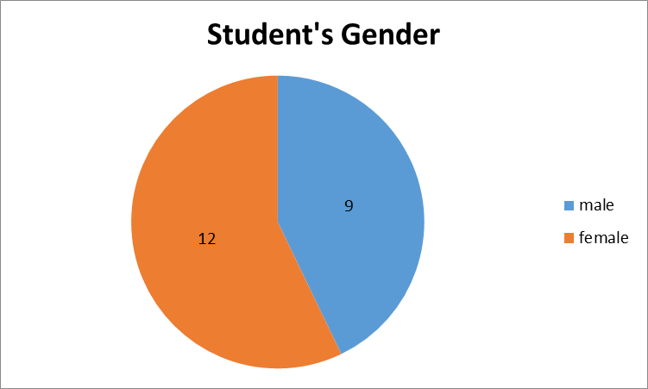

Almost half of the students with migrant background (47,62%) were born in Albania. Almost 24% were born in Greece and about 15% were born in Georgia.
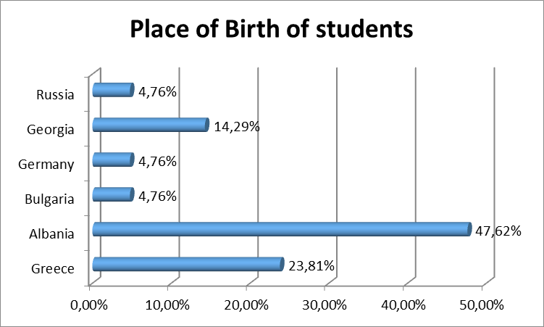

All of the students (100%) answered that they stay with their family at family home or apartment. About 20% of the students don’t stay with both their parents. Also it is important that about 20% of the students work together with the school. About 90% of the students answered that they choose their school together with their parents. About 20% of the students answered that they failed in school one time. About 40% of the students intend to go to the University.

What is more important for the students to be taught in the school, is more professional skills (6 students), knowing the labor market (students) and have a job interview (5 students).
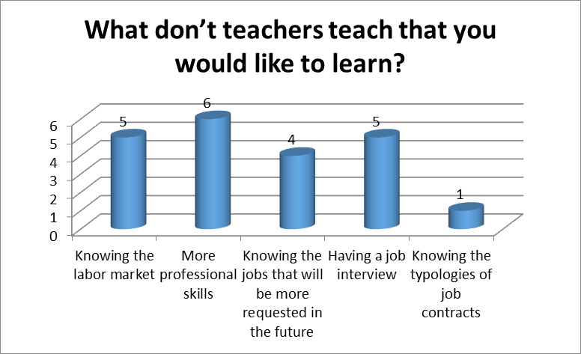

All the students (100%) come to the school by bus. About 80% of the students believe that that have a normal relationship with their teachers. However 23% got sometime a conflict with a teacher because of his/her attitude. Half of the students (52%) answered that sometime they have been bullied. Around 70% of the students replied that they want to change something at the education system, mostly the teaching methodology and greater collaboration between teachers, children, and parents.

