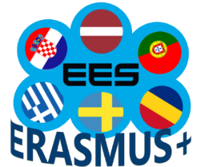

Project Nr. 2018-1-LV01-KA229-046952
„Effective e-learning system based on digital competences”
C4 Joint Staff Training (virtual) in Braga, Portugal
Group work (May 21)
- Introduce yourself: name, school and subject you teach.
- Evaluate your participation in the training. How much have you managed to do? What was the most difficult/ the easiest tool/ platform for you?
- Tell which tool/ platform presented during the virtual training you find the most effective/ motivating for your students.
- Share your experience: the digital tool/platform or method which you find the most effective teaching your students on-line.

