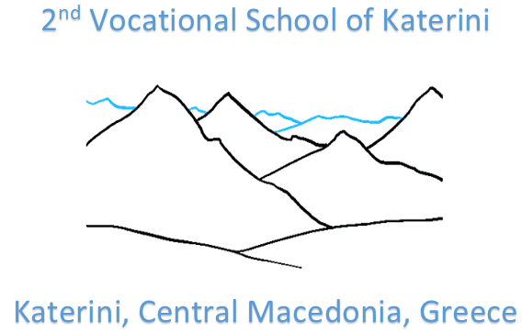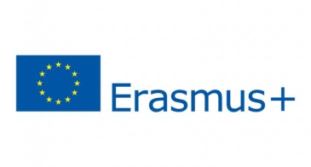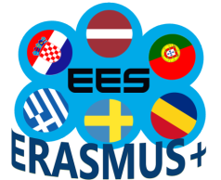

Project Nr. 2018-1-LV01-KA229-046952
«Effective e-Learning System Based on Digital Competences»
C3 Short-term exchanges of groups of pupils meeting in Katerini, Greece

PROJECT MEETING EVALUATION FORM (STUDENTS)
Please fill the following:
No. | - Meeting Organization | 1  VERY LOW | 2  Low | 3  Medium | 4  High | 5  Very High
1.2 | General organization during the meeting
1.3 | Duration and timing of the meeting
1.4 | Domestic arrangements (accommodation, meal, transportation, etc.)
1.5 | Any other comments for the future:
No. | - Meeting Contents and Participation | 1  VERY LOW | 2  Low | 3  Medium | 4  High | 5  Very High
2.1 | I found the activities motivating for me.
2.2 | I got actively involved in the activities and group work.
2.3 | There was a balance between different type of activities (work session, social and cultural events, team building, free time, etc.) realistic timescales
2.4 | I felt comfortable in the group and accepted by other students.
2.5 | I improved my communication, team work and cooperation skills.
2.6 | I improved my IT skills.
2.7 | I impoved my English language skills.
2.8 | The meeting fulfilled my personal expectations
2.9 | What activities did you find most useful? What activities did you find less useful?
No. | - Cultural Activities | 1  VERY LOW | 2  Low | 3  Medium | 4  High | 5  Very High
3.1 | Did you like the cultural activities organized?
3.2 | Did you like the hosting town?
3.3 | Did you learn useful info for the hosting country?
3.4 | Did you like Aiges - Vergina museum ?

No. | - General Impression | 1  VERY LOW | 2  Low | 3  Medium | 4  High | 5  Very High
4.1 | My general impression for this meeting is….

6. What will you take home with you? Tick….
Good memories from hosting town/country

New ideas, skills and inspiration for future work

New contacts/friends

New knowledge/information about other European people

Good atmosphere

Motivation for European projects

Useful discussion/information/exchange of experience, ideas, methods

