IHAVET Questionnaire Results for Teachers
Random Sample on 2nd Vocational School of Katerini

The sample used for the questionnaire is random and consists of the teachers that work at the 2nd Vocational School of Katerini. We collected answers from 20 teachers. More specifically, 65% of the sample (13 teachers) are female and 35% of the sample (7 teachers) are male. 90% of the teachers born in Greece and only two of them were born in Germany.
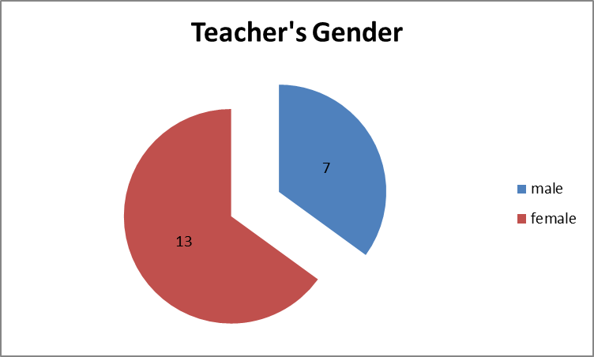

The majority of the teachers are between 46-50 years old. About 60% of the teachers are below 50 years old.
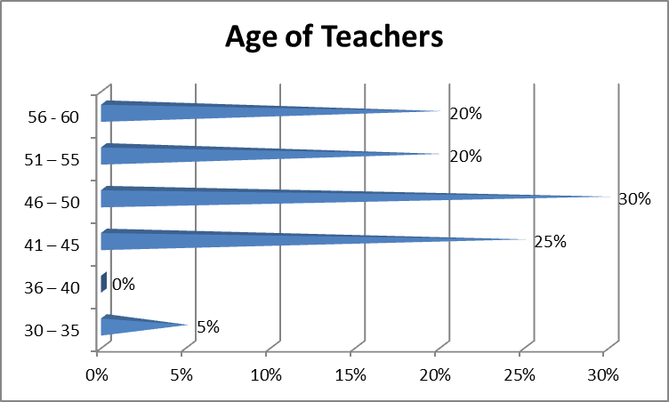
About 60% of the teachers have no specific skills in order to teach students with migrant background. Almost all of the teachers (except one) answered that take into consideration past experiences and/or skills of the children. Concerning the difficulties that immigrant students have, most of the teachers answered that the problems are related to the language. 90% of the teachers answered that migrant children integrated into the class. Another very important point is that the majority (80%) of the teachers answered that the relationship with parents of students with migrant background is scarce. 95% of the teachers answered that they update the parents about the goals achieved by their children. Also 95% of the teachers answered that they would like to change something about the education system of the country.

Most of the teachers (about 63%) would like to change the teaching methodology if they had the opportunity to do that.

