IHAVET Questionnaire Results for Parents
Random Sample on 2nd Vocational School of Katerini

The sample used for the questionnaire is random and consists of the parents whose kids are students in the 2nd Vocational School of Katerini in Greece. More specifically we collected data from 16 parents, which 31% of them are male (5 observations), 63% of them are female (10 observations) and 6% of them said “Prefer not to Answer” (only 1 observation).
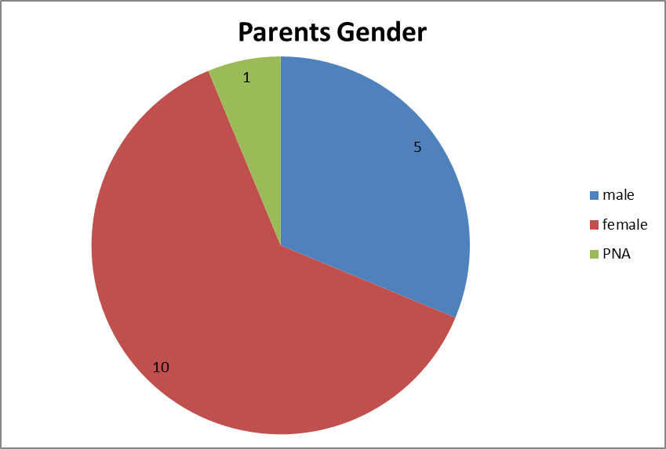

Concerning the country of birth, we can see that the majority of the parents are from Albania (68,75%). Few of them are from Georgia (12,50%) and less are from Romania, Bulgaria and Germany.
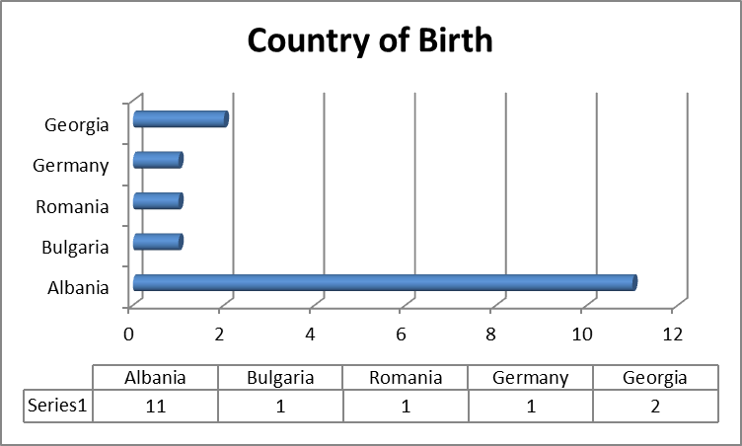

Most of the parents are between 41-50 years old (75%) and only one is over 50 years old.
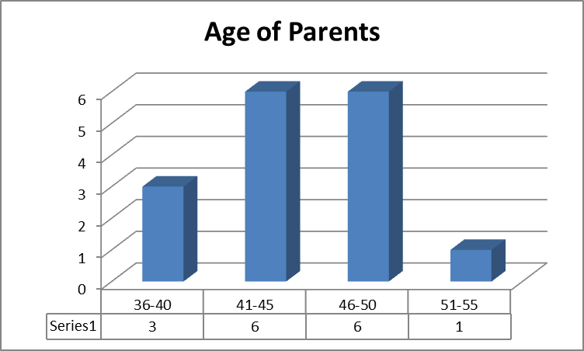

Concerning the education of the parents, we observe that the same number of parents (actually most of them) has a secondary and high school education.
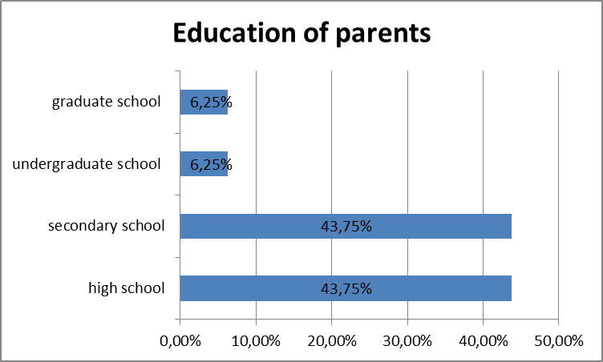

Some important points are :
First of all 94% of the parents have a job either part time or full time and most of them work on an unskilled work. Also about 40% of the parents have some problems with the language, either on speaking, writing or even reading. Only half of them know the student’s teachers and less than 20% participate on the elections of the collegiate bodies of your child's school. Half of the parents answered that teacher is person to be respected and more than 50% answered that they want their kid to go to University. About 60% of them answered that they want to change something to the education, however over 70% answered that the education system provides adequate skills for the labor market.

