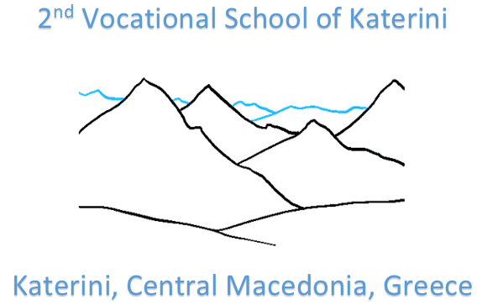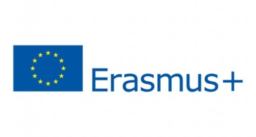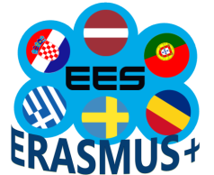

Project Nr. 2018-1-LV01-KA229-046952
«Effective e-Learning System Based on Digital Competences»
C3 Short-term exchanges of groups of pupils meeting in Katerini, Greece

PROJECT MEETING EVALUATION FORM (TEACHERS)
Please fill the following:
No. | - Meeting Organization | 1  VERY LOW | 2  Low | 3  Medium | 4  High | 5  Very High
1.1 | Information (about travel, accommodation, etc) received before the meeting by the host partner
1.2 | General organization during the meeting
1.3 | Duration and timing of the meeting
1.4 | Domestic arrangements (accommodation, meal, transportation, etc.)
1.5 | Any other comments for the future:
No. | - Meeting Contents | 1  VERY LOW | 2  Low | 3  Medium | 4  High | 5  Very High
2.1 | The subjects discussed were relevant
2.2 | The activities were relevant
2.3 | Balance between different type of activities (work session, social and cultural events, team building, free time, etc.) realistic timescales
2.4 | The meeting fulfilled the established objectives
2.5 | The meeting fulfilled my personal expectations
2.6 | What activities did you find most useful? What activities did you find less useful?
No. | - Management and Coordination | 1  VERY LOW | 2  Low | 3  Medium | 4  High | 5  Very High
3.1 | The information (tasks, materials for the meeting, etc.) received before the meeting from the coordinator
3.2 | The coordinator facilitate understanding of the objectives and work plan for the next period
3.3 | The coordinator facilitates communication and collaboration between partners. Everyone was encouraged to contribute to discussion.
3.4 | The coordinator organized well the time for work meetings and cultural events

No. | - General Impression | 1  VERY LOW | 2  Low | 3  Medium | 4  High | 5  Very High
4.1 | My general impression for this meeting is….

6. What will you take home with you? Tick….
Good memories from hosting town/country

New ideas and inspiration for future work

New contacts/friends

New partners/ideas for future project/activities

New knowledge/information about other European people

Good atmosphere

New ideas for implanting and coordinating European projects

Motivation for European projects

Useful discussion/information/exchange of experience, ideas, methods

